GitHub Repository:
https://github.com/2603466/WeeklyLabs

Docker Mount & Run:
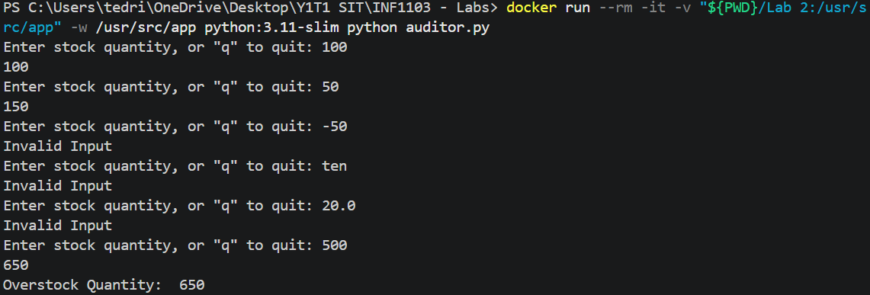

Docker Build:
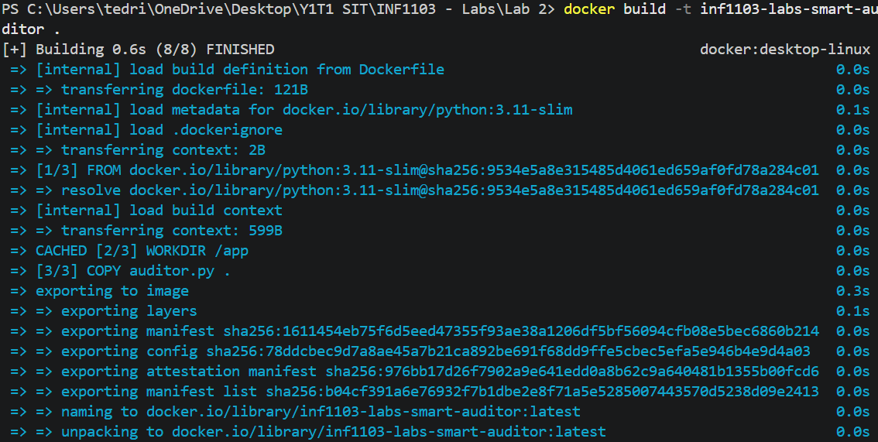

Docker Images:
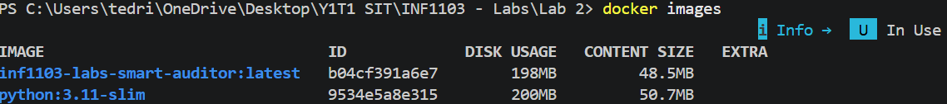

Proof that image runs:
